**Java Features**

1. Object Oriented
2. Java is compiled and interpreted programming language
3. Java is a two-stage system
4. Platform Independent
5. Java is distributed programming language
6. Robust & Secure Programming Language
7. Supports automatic memory management
8. Multithreaded programming language
9. High performance
10. Simple & Familiar syntax
11. Java is dynamic programming language

Why Java is called as compiled and interpreted programming language?

|  |
| --- |
| In Java we use 2 types of translators those are   1. Compilers 2. Interpreters   So, it is called as compiled and interpreted programming language |

What is a bytecode?

|  |
| --- |
| 1. It is an intermediate code which is understandable by Kalakeya called JVM. 2. JVM understandable code. 3. It is called as byte code because each character of generated byte code occupies only 1 byte memory. |

Why JIT compiler was introduced?

|  |
| --- |
| To make the program translation faster during program execution if iterative statements found. |

How JIT and Java interpreter behaves

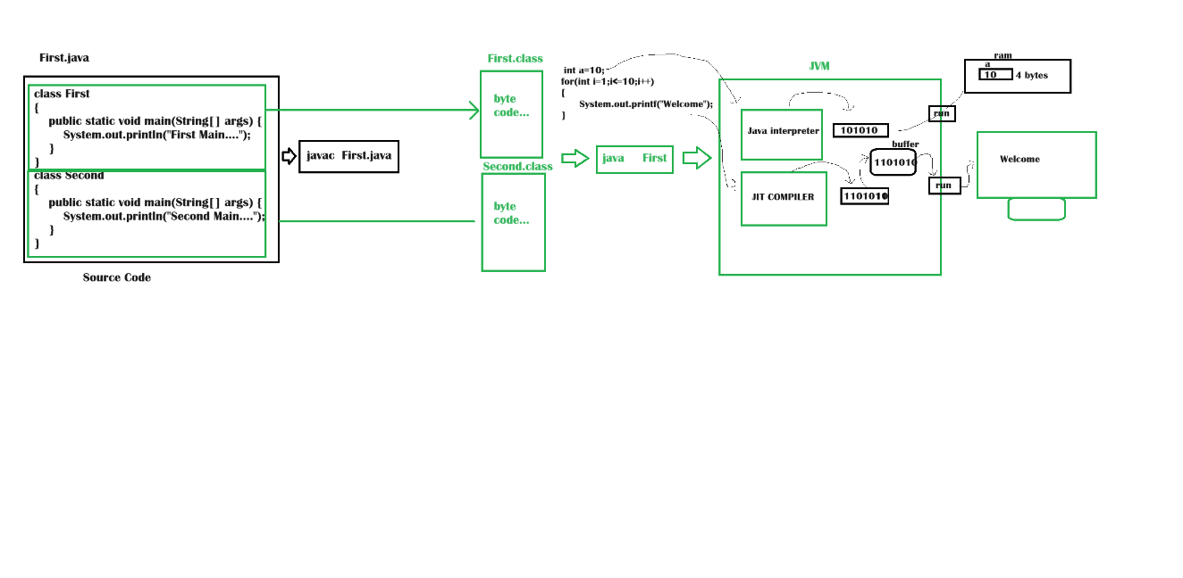

**Java is platform independent**

|  |
| --- |
| 1. The software developed in Java can be executed in any operating system but we need a corresponding JVM 2. If we compile the program then byte code will be generated, we can run that byte code in any operating system with the support of JVM 3. Remember JVM is platform dependent, because the JVM which is installed in one OS can’t be installed in another OS. |

**Java is distributed programming language**

|  |
| --- |
| Java is called as distributed programming language because here we can develop applications that can distribute the data |

**Java Robust**

|  |
| --- |
| The applications developed in Java won’t terminate or hang in middle of execution.   1. Exception handling 2. Automatic Memory management |

**Garbage Collector**

|  |
| --- |
| 1. Java supports automatic memory management in heap memory 2. Garbage collectors destroys the object from heap memory if those objects are in out of scope. 3. Garbage collector uses mark and sweep algorithm |

**Java is called as secure programming**

|  |
| --- |
| 1. In Java many features were introduced to develop secure application so it is called as secure programming language |

**Java is multithreaded programming language?**

|  |
| --- |
| We can run multiple tasks at a time by using threads |

**High performance**

**Simple and familiar**

**Java is dynamic programming language**

|  |
| --- |
| The libraries which are used in our program will be loaded during program execution, not before program execution starts. That is why Java is called as Dynamic programming language. |